#include<iostream>

using namespace std;

int main(){

**Task 1:**

// int score;

// cout<<"put your marks : ";

// cin>>score;

// if(score>=90 && score<=100){

// cout<<"'the student has achieved the grade A ";

// }

// else if(score>=75 && score<90){

// cout<<"the student has achieved the grade B ";

// }

// else if(score>=60 && score<75){

// cout<<"the student has achieved the grade C ";

// }

// else if(score>=45 && score<60){

// cout<<"the student has achieved the grade D ";

// }

// else if(score>=0 && score<45){

// cout<<"the student has achieved the grade F ";

// }

// return 0;

//

**Output:  
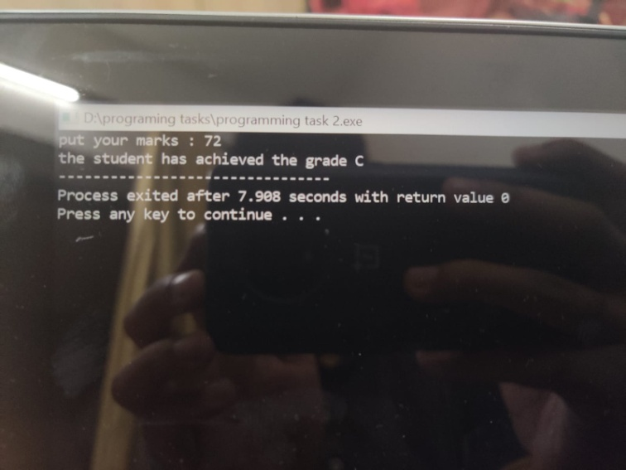**

**Task 2:**

// int a;

// cout<<"put the input there: ";

// cin>>a;

// if(a%2==0 && a%5==0){

// cout<<"the number is an even number and a multiple of 5 ";

// }

// else if(a%2==0 && a%5!=0){

// cout<<"the number is an even number and not a multiple of 5";

// }

// else if(a%2!=0 && a%5==0){

// cout<<"the number is not an even number but a multiple of 5 ";

// }

// else if(a%2!=0 && a%5!=0 ){

// cout<<"the number is not an even number nor multiple of 5";

// }

**Output:**

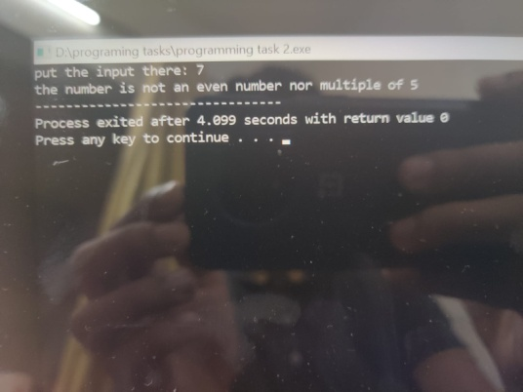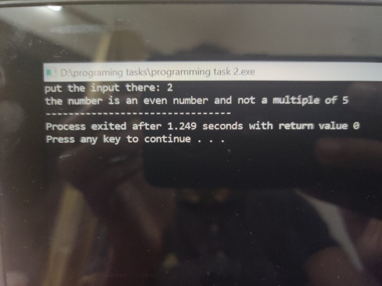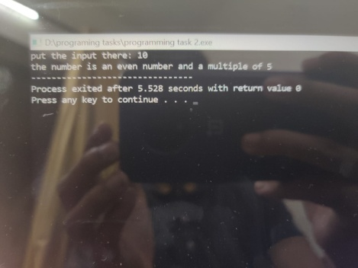

**Task 3:**

// float c,d;

// cout<<"put GPA there:\n ";cin>>c;

// cout<<"'put attendance percentage there: ";cin>>d;

// if(c>=3.5 && d>=80)

// {

// cout<<"the student is eligible for scholarship ";

// }

// else{

// cout<<"the student is not eligible for the scholarship ";

// }

//

**Output:**

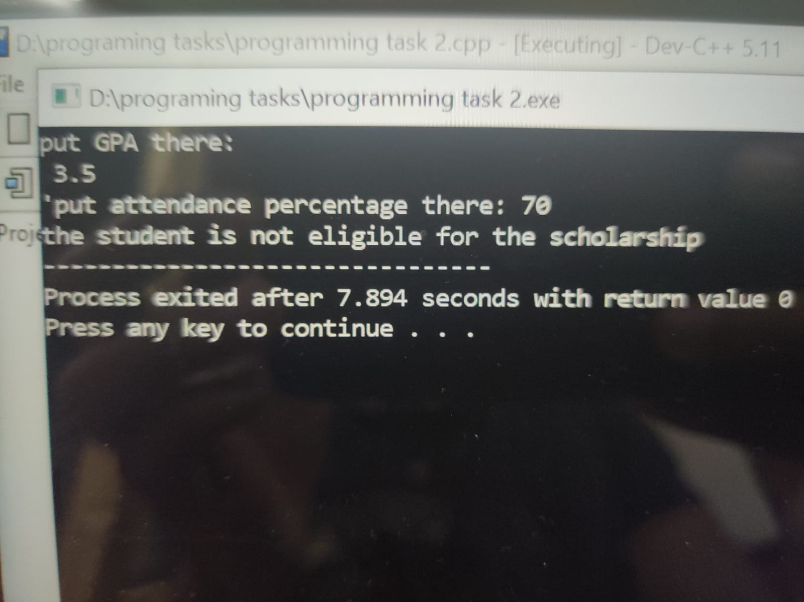

**Task 4:**

// char nust;

// cout<<"put the alphabet there: ";

// cin>>nust;

// char pieas='a';

// char giki='e';

// char uet='i';

// char pu='o';

// char gc='u';

// if(nust==pieas || nust==giki || nust==uet || nust==pu || nust==gc){

// cout<<"the alphabet is a vowel ";

// }

// else{

// cout<<"the alphabet is not a vowel ";

// }

//

**Output:**

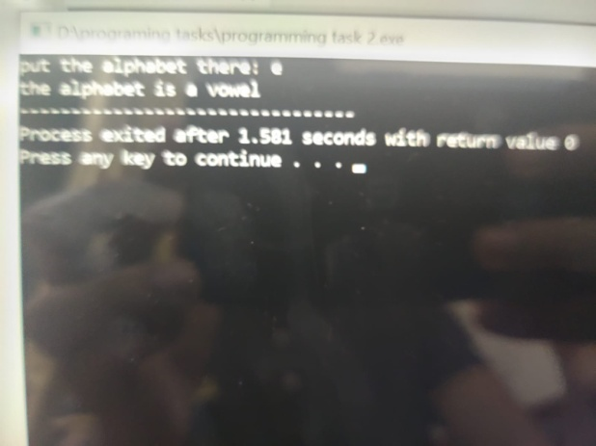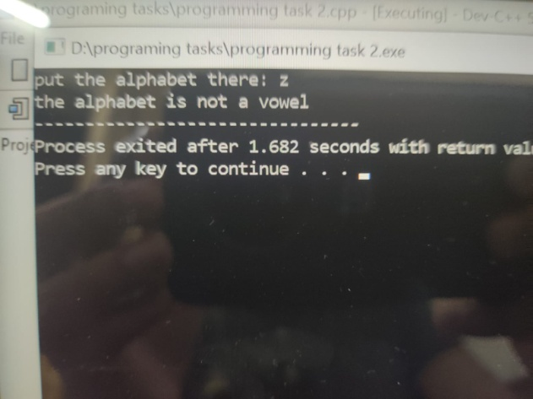

**Task 5:**

int year;

// cout<<"enter year there: ";

// cin>>year;

// if(year%400==0){

// cout<<"the year is a leap year ";

// }

// else if(year%100==0){

// cout<<"the year is not a leap year ";

//

// }

// else if(year%4==0){

// cout<<"the year is a leap year ";

// }

// else{

// cout<<"the year is not a leap year ";

// }

**Output:**



